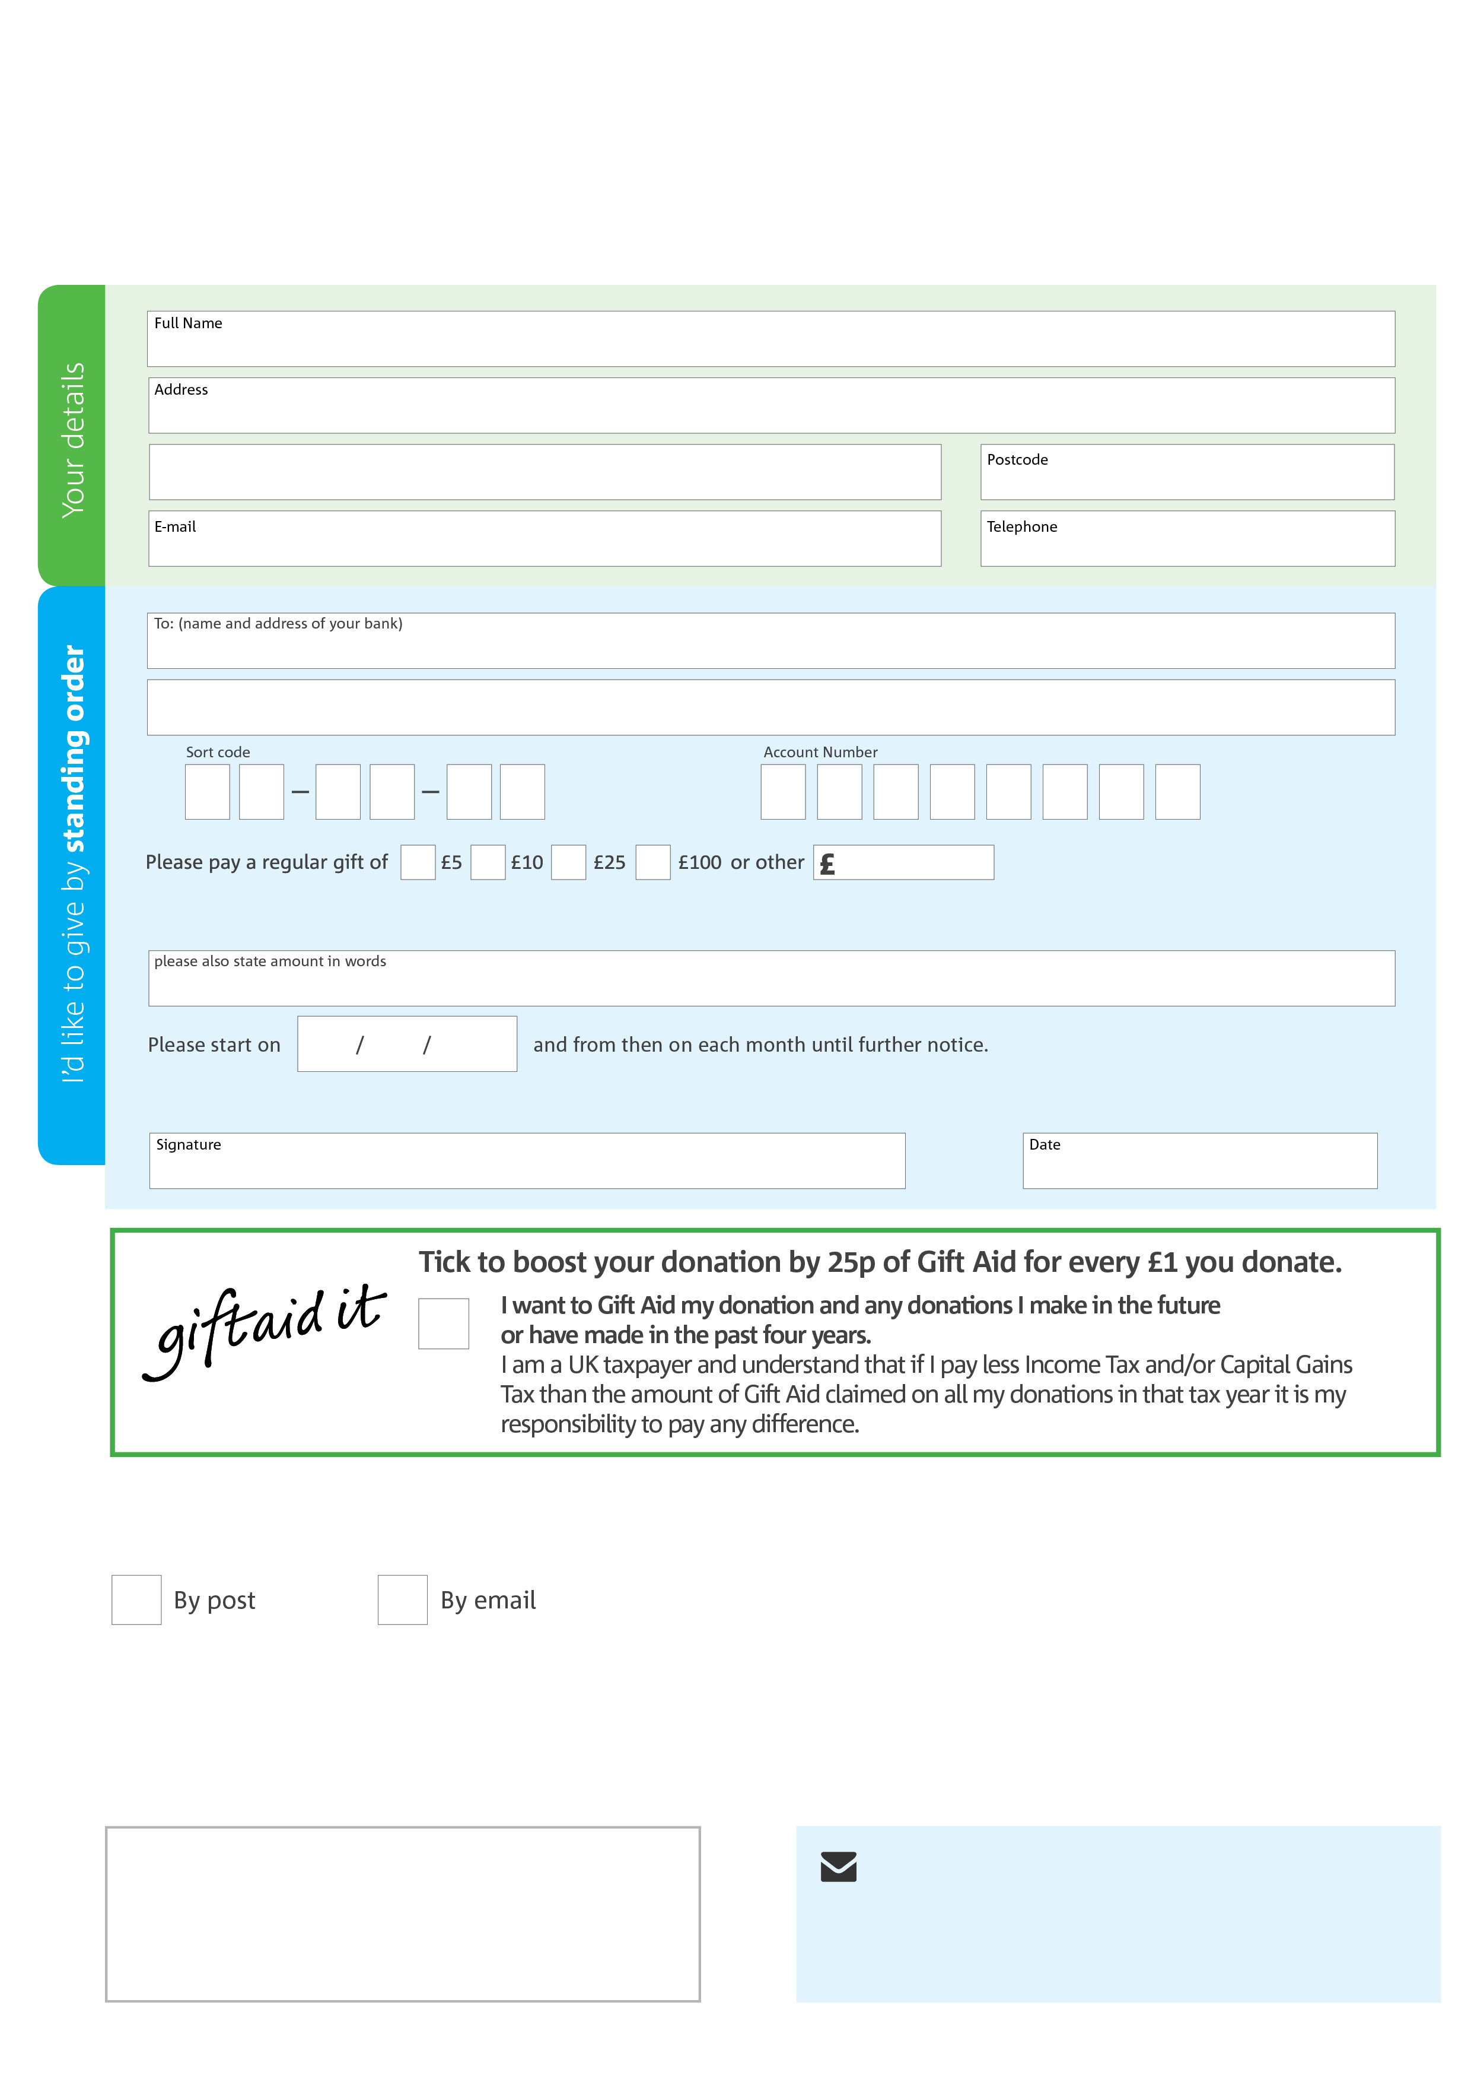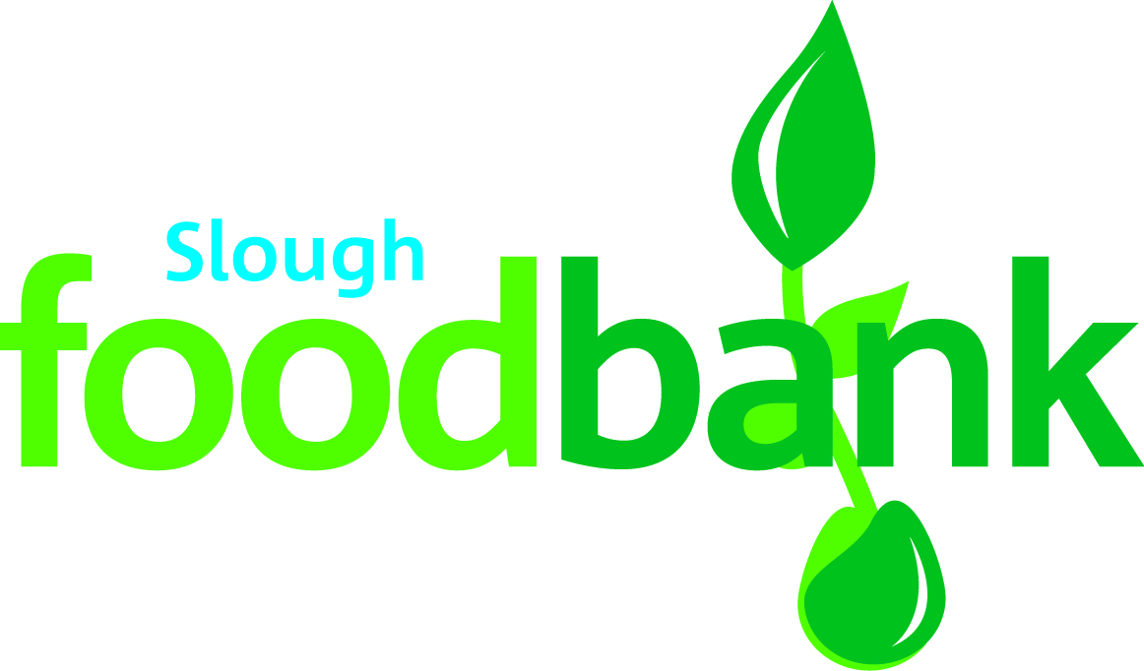­

**Data protection**

Slough Foodbank is committed to protecting your privacy and will process your personal data in accordance with current Data Protection legislation. Slough Foodbank collects information to keep in touch with you and supply you with information relating to our work. To unsubscribe from our newsletter, send a message to the email address above with the word unsubscribe in the subject line. A full data privacy statement for financial donors is available from the foodbank on request.’

**We would love to keep in touch with you so we can update you on our work. You can change your preferences any time by contacting us on 01753 550303 or emailing us at** [**accounts@slough.foodbank.org.uk**](mailto:accounts@slough.foodbank.org.uk)**.**

**Please tick here if you would be happy to receive communications from us:**

**Slough Foodbank’s bank details:**

**Address:** Co-operative Bank, PO Box 250, Delf House, Southway, Skelmersdale, WN8 6WT

**Sort code:** 08-92-99

**Account number:** 65695489

**Please send your completed standing order form to your bank.**

This cancels any previous standing order instructions to Slough Foodbank

To Slough Foodbank each month,

slough.foodbank.org.uk

Reg. Charity No: 1153813 | Reg. in England & Wales