Support
RIDE FOR FOOD 2019

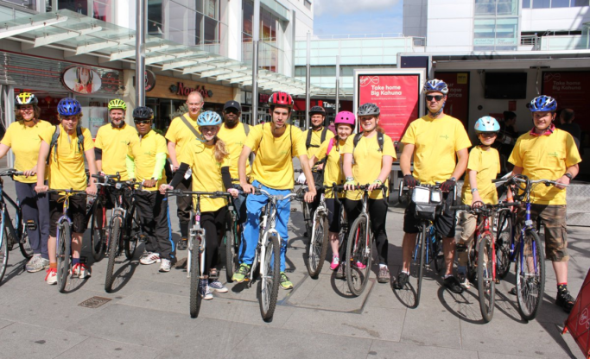
Join us for our 9th Annual Ride for Food
SUNDAY 15TH September
Bring your bicycle for photos at 12.15
Herschel Park Nature Reserve car park, Slough SL3 7NR
For info on how to register or donate contact: Josie on 07429 449611
office@slough.foodbank.org.uk
www.slough.foodbank.org.uk

